The Lewisburg Community Garden staff are here to ensure your gardening experience with us is enjoyable and stress-free. In order to maintain our level of service and the programs we run during the growing season, we ask that you as our plot renters are respectful of the space in the ways described in the contract. Here are some important notes for you to bear in mind:
General Guidelines
- The Garden is open from sunrise to sunset between May 1st and October 31st, unless practicing season extension. The garden is closed during heavy rain and flood conditions. If the word “severe” appears in the forecast, it is best to stay inside and safe.
- Walk only on the gravel/mulch pathways. Please do not leave pets and children roam the garden unattended. You are responsible for any damages they may cause.
- If you are the last person at the garden, please close and chain the gates. An open gate is the easiest way for groundhogs and other pests to enter the garden and wreak havoc on everyone’s plants.
- Keep an eye out for upcoming events on the Garden bulletin board. This is a simple way to stay in touch with community and garden events (like potlucks and Enrichment Series classes). If you wish to post something on the bulletin board, please contact Kyle Bray.
- Parking is available on North Front Street (except Monday between 7AM and Noon) and in Ogren Alley. If parking in Ogren Alley, please do not block the driveway to the white house. Short-term parking in the grass is allowed as long as the borough is not mowing.
- The Communal Plot is meant to grow food for our local food banks and hot meal programs. Please be respectful of the produce and garden beds.
- No permanent structures means no permanent structures. Please refrain from using chemically treated woods or plastics when alternatives are available.

Water use
We recently upgraded our irrigation system to allow plot renters and the communal plot to use water at the same time. We also moved our frost-free hydrant closer to the corner of the garden. These upgrades are meant to make your experience easier, but we ask that if you are the last person to use the water, please turn off the hydrant.
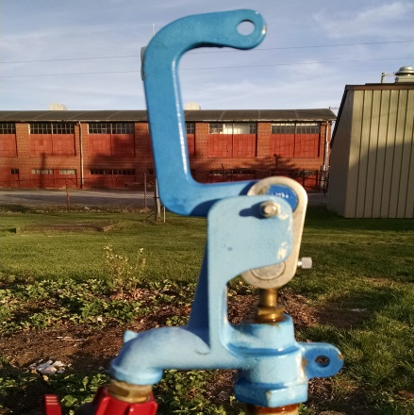
Hydrant turned OFF Hydrant turned ON Hydrant NOT ON or OFF

Plot Maintenance and Upkeep
For organic gardeners, the only inevitable things in life are death, taxes, and weeds. As stated in your contact, you are responsible limiting the spread of weeds from you plot to the best of your ability. The two best ways to limit weeds?
- Put down a layer of mulch as soon as your plants are established. Mulch blocks light from reaching the soil and prevents weeds from germinating. It also provides essential nutrients and helps retain soil moisture, making it easier to remove weeds in your plot.
- Visit your plot often and pull weeds each time you visit. This will stop them from spreading to other plots.
If weeds or rotting produce (see below) become an issue, you will be contacted by LCG staff about the issue. If left unresolved, you could lose your plot.

Trash and Recycling
Please be considerate when disposing of refuse materials. Recycle whenever possible. A trash can is located next to the main gate/bulletin board. Recycling can be placed in the bin next to the shed. Before you throw something out, ask yourself if it can be reused!

Gleaning
According to the nonprofit organization Feeding America, 25-40% of food grown, picked, transported, and sold will go to waste. Imagine yourself going to the grocery store and buying food, only to leave just under half your grocery bags in the cart as you leave. Food waste is a 70 billion pound per year problem in this country. One of our renewed goals for this year is to eliminate as much food waste as we can through gleaning.
The act of gleaning is to art of collecting leftover crops after harvest. Sometimes, it is not economically feasible for farmers to pick all their produce if it won’t meet market standards – so they allow groups to glean their perfectly edible produce! We will glean produce after giving three (3) days’ notice and donate it to our existing network of local food banks and hot meal programs. If left unresolved as specified in your contact, we will glean your produce to ensure it is not wasted. The best way to stop us from gleaning is to visit your plot regularly.
Common produce that faces this problem are tomatoes and peppers. We won’t be able to save every tomato, but we will find a better home for otherwise wasted produce than the ground.
The gleaning clause of the contract is brand new this year. There is always the possibility of unexpected problems arising with the system. If you have excess produce you wish to donate, the best times to do so are at garden are Tuesday and Thursday afternoons during our volunteer hours. Please let us know when you will be on vacation and if we are able to harvest for you while you are away. Please be patient with us as we figure out the best balance between reconciling your needs with the mission of the Garden.

Composting
The garden has two compost bins located along the river-side fence. They are a three-bin system; the leftmost of each for fresh green/brown matter. The compost moves to the right as it ages, with finished compost in the rightmost bin. While this system works, it is by no means perfect. In the past, we have had issues with green matter finding its way into the wrong bins and severe overflow issues. Please discard any excess green matter to the LEFT side of the compost bins in a pile.
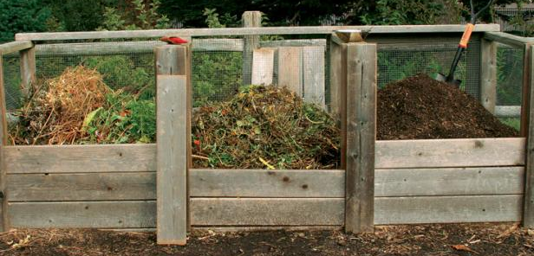
Finished compost

New matter

Decomposed matter

If at all possible, please tear/shred/chop compostable materials before placing in bins. Smaller pieces will decompose faster and reduce the amount of time from trimming to finished compost.
Although controversial, we compost our weeds with our garden trimmings. We will continue to do so until better practical methods are put into place.

Your Suggestions & Feedback!
The LCG staff is always open to new ideas about how we can do better each and every year. At the end of the season, you will have the option to take a survey about your experience with us and offer any feedback. Please contact us if you have any suggestions, concerns, or things we may be missing!

